  - ANU Summer Research Final Report

Prediction of nanobodies and antigens binding by machine learning
Nhan Khanh Vu, Thomas Huber

School of Chemistry, Australian National University

Contact email: Nhan.Vu@anu.edu.au

Introduction
Nanobodies are a special class of molecules that are derived from heavy-chain only antibodies present in camelids. Discovered in 1993, these molecules offer several advantages due to their reduced size, enhanced stability, solubility (Hamers-Casterman et al, 1993). Despite of their reduced size, the binding affinities of nanobodies are greater than that antibodies. Nanobodies achieved this by having a more reserved framework region, and more diverse in their complementarity-determining regions (CDRs) (Mitchell and Colwell, 2018).
The distinctive features of nanobodies make them highly suitable for a range of medical applications, particularly in cancer therapeutics. Their small size enables better tissue penetration, while their specificity and affinity for particular antigens allow for targeted approaches from molecular imaging and targeted drug discovery to direct therapeutics interventions (Yang and Shah, 2020). In cancer therapy, nanobodies have been engineered to target tumor-specific markers, providing a pathway for the targeted delivery of therapeutics agents directly to cancer cells, therby minimizing the side effects associated with more conventional treatments. (Behdani et al, 2013).
In recent years, the intersection of bioinformatics and machine learning has revolutionized our approach to solve complex biological problems. In antibodies-antigen binding problems, machine learning has shown some very promising results so far. A study by Makowski et al 2022 has demonstrated the use of machine learning models in simplifying antibody co-optimization , predicting metrics correlated with antibody affinity and non-specific binding. The Absolut! Software, developed by Philippe A. Robert et al 2022, allows for the generation of synthetic antibody-antigen structures for machine learning tasks, providing a significant benchmark for machine learning strategies in biotherapeutics design.
On nanobodies-antigens binding problems, machine learning are also increasing employed to predicting the binding affinities of these molecules. For instance, recent advancements in machine learning-guided re-ranking of nanobody-antigen binding poses have shown significant improvements in the prediction accuracy of nanobody binding, surpassing existing computational methods. (Tam et al, 2021). Additionally, machine-learning methods have been developed to predict nanobody-antigen binding solely based on sequence data, achieving up to 90% accuracy (Sardar et al, 2023).
Furthermore, the integration of machine learning in the development of nanobodies also extends to addressing broader immunological challenges. For example, the PanPep method, based on meta-learning and neural Turing machine architecture, provides a robust framework to recognise TCR-antigen binding, including with unseen antigens, thus offering broad clinical applications in immunotherapy (Gao et al, 2023)
In this report, we managed to get a larger dataset of 800 nanobodies over 1400 PDB IDs than all the previous work has done. We also introduced the novel approach that instead of feeding the machine the entire sequence, we extracted the CDR region from the nanobody and the epitope region from the antigen. We have got the accuracy up to 79% on the whole dataset by the deep neural network

Methods
Dataset
The dataset of 800 nanobodies spanning over 1400 PDB IDs were taken from the integrated nanobodies database for immunoinformatic (INDI). After downloading the dataset, only the IDs that have at the sequence of nanobodies and antigens were kept and downloaded for further analysis. Using the CDR region available in the original dataset, we search for the sequence that is the closest to this CDR region using the PDB file that contains the position of every atom in the protein.
Find the closest sequence in the PDB file
From 1 PDB file, we store all positions of the C-alpha of every amino acid. From the CDR sequence available, we perform alignments with the nanobodies sequence to find the index of the CDR region and therefore obtain the positions of the CDR region. We search through all amino acid positions in sequences other than the nanobodies itself and find the distance with all amino acid in the CDR region and then count the number of amino acids that has the distance less than 8 Angstrom with the CDR region. The sequence that has the most amino acids with this feature will be the antigens that bind to the nanobodies. After getting the closest sequence, another search will be conducted to find the amino acids that are less than 8 Angstrom distance to the CDR region of the nanobodies, this will be the epitopes region to train the machine learning model.
Getting the concatenated sequence
The concatenated sequences were made by merging the whole CDR region of the nanobodies with the epitope of the appropriate antigens. The wrong binding dataset was constructed by merging the CDR region of one nanobody to the epitope region of another antigen. We got in total 1544 sequences of correct binding and 1542 sequences of incorrect binding.
Sequence embedding
Machines cannot read the entire sequence by itself, we have to encode the sequence in some form of number that it can understand. We decided to code ESM-1b model from Facebook AI research lab (Lin et al, 2023). It has shown great performance on protein-protein interaction tasks (Xu et al, 2024) as well as other tasks like distinguishing multimers and monomers and predicting the quaternary state of proteins (Avraham et al, 2023). Below is the distribution value of one sequence embedding using ESM-1b, the mean value of all is 0.0 and the standard deviation is 0.28
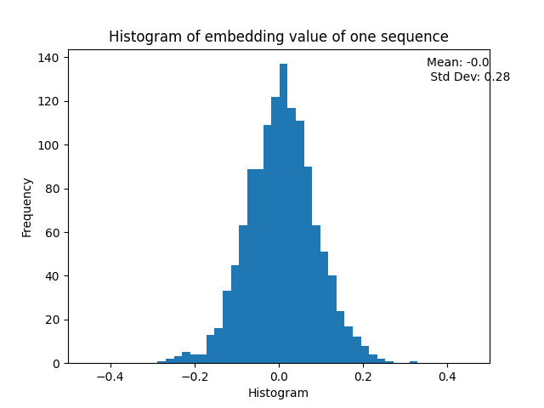
Figure 1: Histogram of one sequence
Train the machine learning model
We built a deep neural network model using PyTorch from Facebook AI research lab. PyTorch’s architecture allows every aspect of it to be controlled by the user as a regular Python program, enabling flexibility and ease of use. The design choice is crucial for achieving compelling performance while maintaining user friendliness (Adam Paszke et al, 2019)
The dataset was applied Standard Scaler to make the mean 0 and the standard deviation to be 1 where every value in the dataset was transformed by
$z=\frac{x-u}{s}$
Where u is the mean and s is the standard deviation of the dataset. Standardizing is crucial for several reasons. It improves the precision in predictive analysis (Ramesh et al, 2022). Moreover, standardizing data ensures that independent features are placed in a fixed range, allowing for fair and accurate comparisons between variables and models (Camilo Parra et al, 2020). Below is the histogram of one sequence embedding after standardizing.
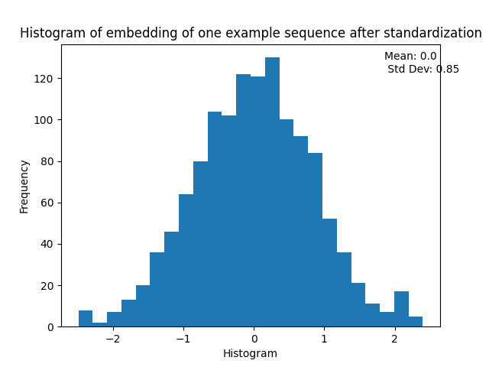
Figure 2: Histogram of embedding value of a sequence after standardizing

The dataset was split 80% to the training data and 20% on the test data. All these steps were made using the scikit-learn machine learning library. We built am artificial neural network with 3 layers, first layer has 256 neurons, second 128 neurons and last layer with 1 neuron. The activation function for the first 2 layers was Rectified Linear Unit (ReLU), for the last layer the Sigmoid activation function. The ReLU function: $f(x)=max⁡(0,x)$ when applies to x return x if x is positive and 0 if it is not. The sigmoid function $f\left(x\right)= \frac{1}{1+e^{-x}}$ return value from 0 to 1 for any value of x. It is used in the final layer of the neural network to classify whether a pair of nanobody-antigen can bind or not.
Apart from that, we also train the machine learning model using 6 different algorithms: Logistic Regression, Support Vector Machine (SVM), Random Forest, K-Nearest Neighbor, Naïve Bayes, and Decision Trees.

Results
Deep learning performance
Precision: 79.81%, recall: 77.61%, F1-score: 78.69%, Accuracy: 77.83%. The receiver operating characteristic (ROC) curve is presented in figure 4.
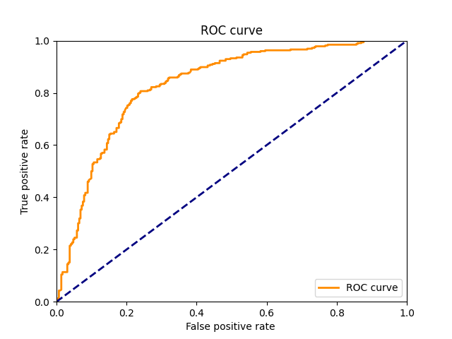
Figure 3: ROC curve of the deep learning model
Other machine learning model performance
The performance metrics of all the algorithms are presented in Table 1. The accuracy of each algorithm is also illustrated in figure 3.
From the table and graph, random forest is the most efficient for this task
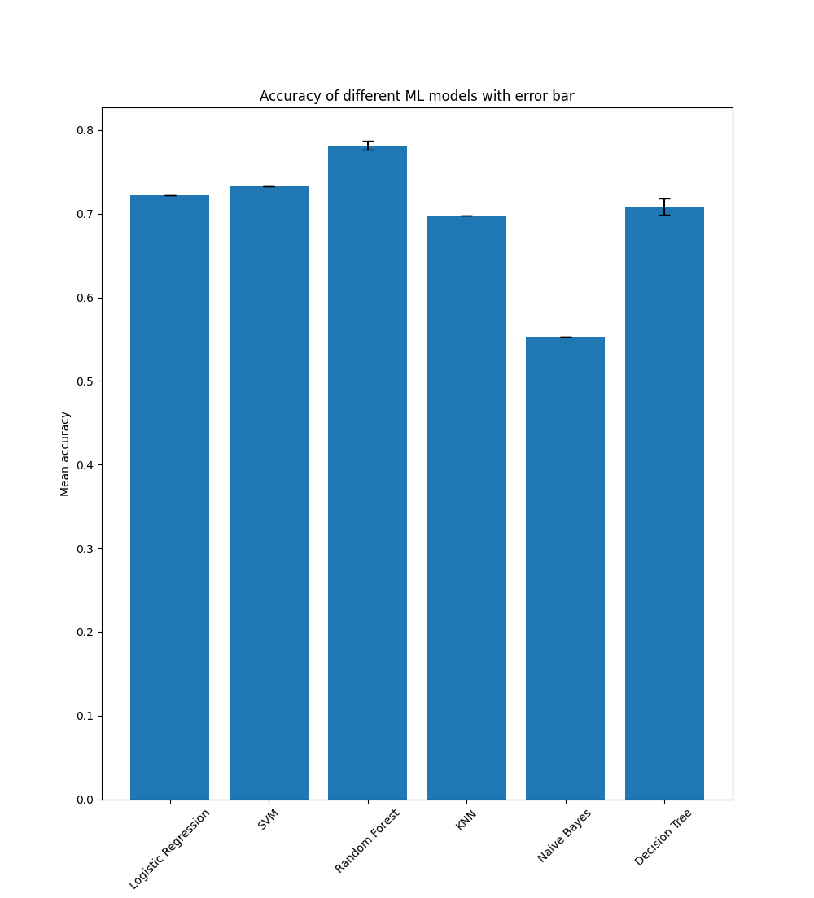
Figure 3: Bar graph of different machine learning algorithms with error rate

Metrics/ Algorithms | Accuracy | Precision | Recall | F1_score | AUC_score
Logistic regression | 0.7217$±$0.0 | 0.7362$±$0.0 | 0.7362$±$0.0 | 0.7362$±$0.0 | 0.7654$±$0.0
Support vector machine | 0.733$±$0.0 | 0.7462$±$0.0 | 0.7485$±$0.0 | 0.7473$±$0.0 | Nan
Random forest | 0.7806$±$0.0092 | 0.8123$±$0.0118 | 0.7598$±$0.0156 | 0.7851$±$0.0096 | 0.8822$±$0.042
K-nearest neighbor | 0.6974$±$0.0 | 0.7075$±$0.0 | 0.727$±$0.0 | 0.7171$±$0.0 | 0.7597$±$0.0
Naïve Bayes | 0.5534$±$0.0 | 0.5687$±$0.0 | 0.635$±$0.0 | 0.6$±$0.0 | 0.5775$±$0.0
Decision Trees | 0.7073$±$0.0064 | 0.7376$±$0.011 | 0.6914$±$0.0085 | 0.7136$±$0.0048 | 0.7153$±$0.0061

Table 1: Other machine learning algorithms model performance

Discussion
Based on all the algorithms, we conclude that random forest is the most effective algorithm to predict the binding of nanobodies and antigens. This is because random forest is an ensemble learning method, meaning it combines predictions from several models to improve accuracy (Breiman, 2001). The core of Random Forest consists of numerous decision trees, each built from a randomly sampled subset of the data (Liaw and Wiener, 2002). This could be attributed to Random Forest’s ability to handle complex interaction data and its robustness against overfitting, which is crucial in biological data analysis (Wang et al, 2023, Cingireddy et al, 2021). On the other hand, Naïve Bayes is the poorest performance of all the algorithms. The reason is that this algorithm works by the assumption that all the features (or predictors) in a dataset are independent of each other (Rish, 2001). In the context of predicting nanobodies- antigens binding, this can lead to suboptimal performance, especially when compared to more sophisticated algorithms like Random Forest that can capture complex relationships.
For future work, as data on this subject is very limited, I will keep training the neural network to get a higher accuracy prediction, and then after that, work backward to design nanobodies based on the sequence of the antigens.

Acknowledgments
I, Nhan Khanh Vu, would like to extend my deepest gratitude to my supervisor, Professor Thomas Huber for their invaluable guidance, support and insightful feedback throughout the course of this summer project. I would also like to thank Burgmann college for providing housing, 3 meals a day the whole summer. Without any of you, I would not be able to finish this summer project on time.

Data and code availability
The data and code can be found this Github link:
https://github.com/thanhchepcode/NanobodyPlayground

References
Avraham, O., Tsaban, T., Ben-Aharon, Z., Tsaban, L. and Schueler-Furman, O., 2023. Protein language models can capture protein quaternary state. bioRxiv, pp.2023-03.
Behdani, M., Zeinali, S., Karimipour, M., Khanahmad, H., Schoonooghe, S., Aslemarz, A., Seyed, N., Moazami-Godarzi, R., Baniahmad, F., Habibi-Anbouhi, M. and Hassanzadeh-Ghassabeh, G., 2013. Development of VEGFR2-specific Nanobody Pseudomonas exotoxin A conjugated to provide efficient inhibition of tumor cell growth. New biotechnology, 30(2), pp.205-209.
Breiman, L., 2001. Random forests. Machine learning, 45, pp.5-32.
Cingireddy, A.R., Ghosh, R., Kar, S., Melapu, V., Joginipeli, S. and Leszczynski, J., 2021. Preliminary Screening of COVID-19 Infection Employing Machine Learning Techniques From Simple Blood Profile. International Journal of Quantitative Structure-Property Relationships (IJQSPR), 6(3), pp.35-47.
Gao, Y., Gao, Y., Fan, Y., Zhu, C., Wei, Z., Zhou, C., Chuai, G., Chen, Q., Zhang, H. and Liu, Q., 2023. Pan-Peptide Meta Learning for T-cell receptor–antigen binding recognition. Nature Machine Intelligence, 5(3), pp.236-249.
Hamers-Casterman, C.T.S.G., Atarhouch, T., Muyldermans, S.A., Robinson, G., Hammers, C., Songa, E.B., Bendahman, N. and Hammers, R., 1993. Naturally occurring antibodies devoid of light chains. Nature, 363(6428), pp.446-448.
Makowski, E.K., Kinnunen, P.C., Huang, J., Wu, L., Smith, M.D., Wang, T., Desai, A.A., Streu, C.N., Zhang, Y., Zupancic, J.M. and Schardt, J.S., 2022. Co-optimization of therapeutic antibody affinity and specificity using machine learning models that generalize to novel mutational space. Nature communications, 13(1), p.3788.
Liaw, A. and Wiener, M., 2002. Classification and regression by randomForest. R news, 2(3), pp.18-22.
Lin, Z., Akin, H., Rao, R., Hie, B., Zhu, Z., Lu, W., Smetanin, N., Verkuil, R., Kabeli, O., Shmueli, Y. and dos Santos Costa, A., 2023. Evolutionary-scale prediction of atomic-level protein structure with a language model. Science, 379(6637), pp.1123-1130.
Mitchell, L.S. and Colwell, L.J., 2018. Comparative analysis of nanobody sequence and structure data. Proteins: Structure, Function, and Bioinformatics, 86(7), pp.697-706.
Parra, C., Ponce, C. and Rodrigo, S.F., 2020, November. Evaluating the performance of explainable machine learning models in traffic accidents prediction in california. In 2020 39th International Conference of the Chilean Computer Science Society (SCCC) (pp. 1-8). IEEE.
Paszke, A., Gross, S., Massa, F., Lerer, A., Bradbury, J., Chanan, G., Killeen, T., Lin, Z., Gimelshein, N., Antiga, L. and Desmaison, A., 2019. Pytorch: An imperative style, high-performance deep learning library. Advances in neural information processing systems, 32.
Ramesh, T.R., Lilhore, U.K., Poongodi, M., Simaiya, S., Kaur, A. and Hamdi, M., 2022. Predictive analysis of heart diseases with machine learning approaches. Malaysian Journal of Computer Science, pp.132-148.
Rish, I., 2001, August. An empirical study of the naive Bayes classifier. In IJCAI 2001 workshop on empirical methods in artificial intelligence (Vol. 3, No. 22, pp. 41-46).
Robert, P.A., Akbar, R., Frank, R., Pavlović, M., Widrich, M., Snapkov, I., Slabodkin, A., Chernigovskaya, M., Scheffer, L., Smorodina, E. and Rawat, P., 2022. Unconstrained generation of synthetic antibody–antigen structures to guide machine learning methodology for antibody specificity prediction. Nature Computational Science, 2(12), pp.845-865.
Tam, C., Kumar, A. and Zhang, K.Y., 2021. NbX: machine learning-guided re-ranking of nanobody–antigen binding poses. Pharmaceuticals, 14(10), p.968.
Wang, D.C., Xu, W.D., Wang, S.N., Wang, X., Leng, W., Fu, L., Liu, X.Y., Qin, Z. and Huang, A.F., 2023. Lupus nephritis or not? A simple and clinically friendly machine learning pipeline to help diagnosis of lupus nephritis. Inflammation Research, pp.1-10.
Xu, X. and Bonvin, A.M., 2024. DeepRank-GNN-esm: A Graph Neural Network for Scoring Protein-Protein Models using Protein Language Model. Bioinformatics Advances, p.vbad191.
Yang, E.Y. and Shah, K., 2020. Nanobodies: next generation of cancer diagnostics and therapeutics. Frontiers in Oncology, 10, p.1182.

